ITP – ROUTE 19 LAUNCH
MEDIA RECAP

The Aug. 27 launch of The Rapid’s fare-free new bus service, Route 19, at Rosa Parks Circle plaza in Grand Rapids was extensively covered by multiple media outlets in West Michigan, including print, radio and all three Grand Rapids TV affiliates representing NBC, ABC and FOX. In addition, one non-media group – West Michigan Environmental Action Council (WMEAC) – provided coverage of the new service, and each news outlet’s coverage generated an overwhelmingly positive sentiment.

WOOD Radio – 106.9 FM & 1300AM (Bulthius interview)
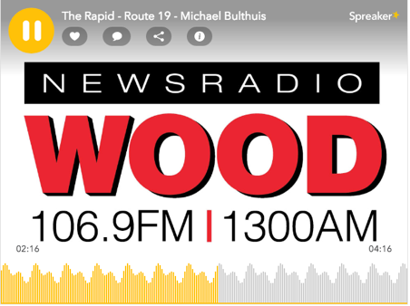

WOOD Radio – 106.9 FM & 1300AM (Feature story)

WOOD-TV 8 (NBC affiliate)

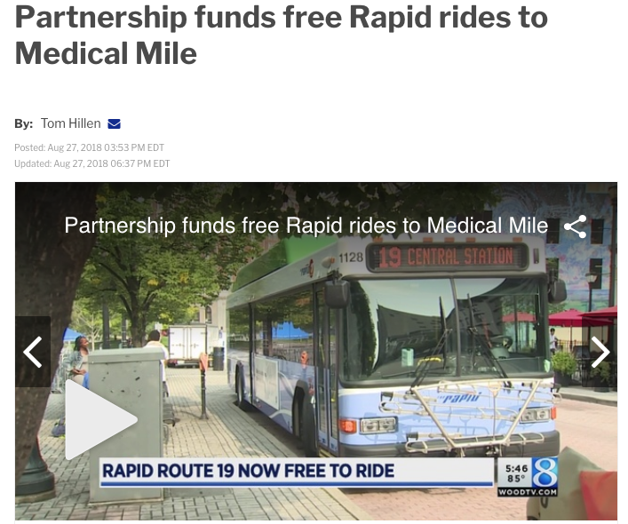
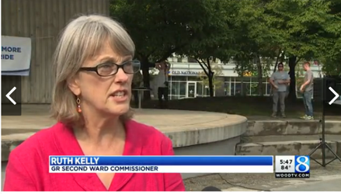

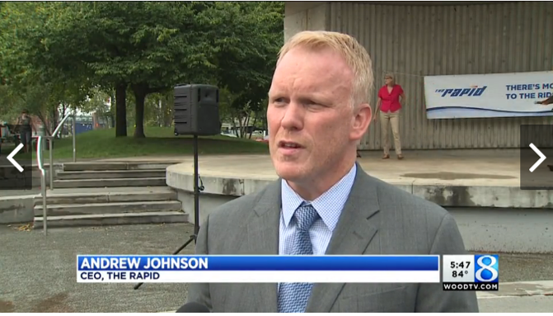

WZZM-TV 13 (ABC affiliate)
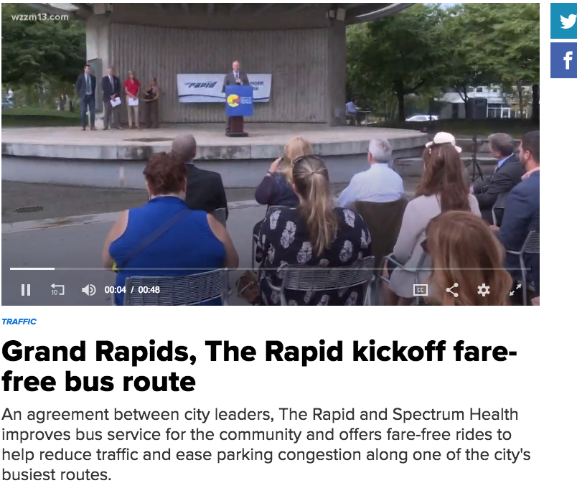

MLive
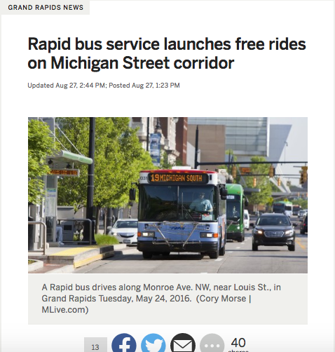

WGVU Radio (NPR affiliate)
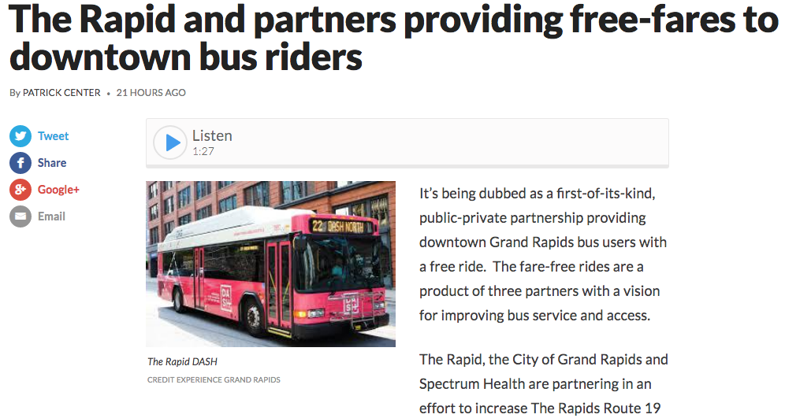

West Michigan Environmental Action Council (WMEAC)

